Shri Ram College of Commerce
18 August, 2021

Notice

Subject change requests for Generic Elective and/or Skill Enhancement Course (Commerce)- Semester III

This is to inform the students who are desirous of submitting a subject change application wrt the Generic Elective and/or Skill Enhancement Course (Commerce)- Semester III, are required to submit their application to the TTC Convenor at ttc.commerce@srcc.du.ac.in latest by 21-08-2021 (Saturday). No requests shall be accepted post this deadline. Request for any new subject will not be entertained.

TTC Commerce

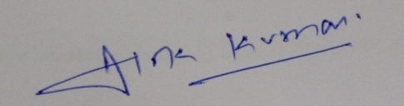

Dr. Alok Kumar

Dr. Alok Kumar
Convenor, TTC (Commerce)

